Table of Contents
Introduction
Vision
Aim
Objectives
Methodology
Ransomware
Organisation
RACI Matrix for Ransomware Policy Creation
RACI Matrix for Ransomware Policy Implementation
Strategy
Strategic Principles
Prevention Strategy
Backup Recovery
Detection and Response Strategy
Organisation’s stance on Ransom
Communications Strategy
Governance and Accountability
Continuous Improvement
Policies
Roles and Responsibilities
Strategic Objectives
Policies and Standards
Regulatory Compliance
Budget and Allocation
Risk Management Approach
Risk Appetite
Risk Assessment Process
Control Objectives
Control Implementation
Control, Monitoring, and Auditing
Incident reporting and escalation
Incident response plan
Post-incident analysis
Training and Education Programmes
Continuous Monitoring
Audit and Review
Reporting
Review and update cycle
Feedback Mechanisms
Procedure
Ransomware Prevention Procedures
Ransomware Incident Response Procedures
Ransomware Governance and Compliance Procedures
Management
Operational Security Practices
Technical Controls and Prevention
Response and Recovery
Collaboration
Before an Attack
During an Attack
After an Attack
Continuous Improvement
Conclusion
References

INTRODUCTION
Televula is a large enterprise with 1,500 employees that offers software products primarily used by health-sector companies. With the rise of AI, attackers can accelerate their attack processes by using it to speed up research, reduce the time needed to analyse large datasets, and understand attack paths in real time (IBM, 2026). Healthcare providers remain lucrative targets, as illustrated by the ransomware attack on kidney dialysis company DaVita Inc., which resulted in the loss of an estimated 2.7 million patient records and approximately 1.5 TB of clinical data (Chainanalysis, 2026). This situation positions the organisation as a significant supply chain risk to the healthcare organisations it supports, highlighting the need for the organisation to develop a methodology and adopt best security practices to counter this evolving attack vector.
Vision: To develop Level 5 threat preparedness against ransomware as the attack methods continue to grow and change.
Aim: To protect the confidentiality, integrity, and availability of organisational assets from ransomware attacks by creating a consistent and systematic approach to various attack scenarios.
Objectives: This policy aims to:
- Clearly define accountability roles for information security in the context of ransomware attacks.
- Ensure compliance with legal and regulatory requirements.
- Establish clear procedures to promptly detect, report, and respond to ransomware incidents.
- Identify and regularly assess ransomware risks to keep them manageable.
- Continuously monitor, review, and improve the ransomware policy to adapt to evolving threats, technology, and business needs.

METHODOLOGY
A structured, iterative approach aligned with the Plan-Do-Check-Act cycle, a requirement of the information security management system under the ISO 27001 standard, will be used to incorporate the ransomware policy into the existing system. It acts as an internal audit check to be conducted before understanding the necessary processes of ISO 27001 and would be especially helpful for including the new ransomware policy into the organisation's current information security management system. (The ISO Council, 2022).
RANSOMWARE
Ransomware is a type of malicious software (malware) that blocks individuals or organisations from accessing files on computers, systems, or networks and demands a monetary sum to restore access. It often disrupts organisational operations and causes the loss of vital data (FBI, n.d.).
There are two main types of ransomware: encrypting and non-encrypting. Encrypting ransomware restricts the victim’s access to their data by encrypting it and demanding a significant sum in exchange for the decryption key. Non-encrypting ransomware restricts access to the entire device, usually by blocking access to the operating system. Ransomware attacks have evolved to include double-extortion attacks, which add the threat of selling the victim’s data online, and triple-extortion attacks, which threaten to use stolen data to attack the victim’s customers or business partners (IBM, 2024).
Some common methods of infection include phishing and other social engineering attacks; exploiting vulnerabilities in operating systems or software, especially zero-day vulnerabilities; stealing unauthorised user credentials by purchasing them on the dark web or through brute-force methods; and drive-by downloads, where hackers embed ransomware into websites that infect devices without users’ knowledge. Ransomware-as-a-service has also become a common approach, in which malware developers provide the ransomware code, and attackers carry out the attacks, sharing the profits with the developers (IBM, 2024).
Ransomware attacks are usually carried out in a structured, methodical manner. The stages within which they are carried out include (IBM, 2024):
- Initial Access: The point at which an attacker first gains access to a computer system or organisational network.
- Post-exploitation: This stage involves the attacker deploying additional tools or malware to gain a foothold on the victim’s system or network.
- Understand and Expand: The attacker aims to assess their current access level and then expand to other domains or systems within the network during this phase.
- Data collection and exfiltration: The attacker switches the focus to identifying and extracting sensitive information during this phase of the attack.
- Deployment and sending the note: This phase involves the attacker restricting access to the victim's system or network and notifying the victim of the restriction and a corresponding sum to pay to regain access.

Ransomware attacks show no signs of stopping anytime soon, with ransomware attacks on organisations such as:
- Marquis Health: On February 24th, 2026, the ransomware breach was attributed to a SonicWall cloud backup hack, allowing unknown attackers to encrypt data and disrupt the organisation’s operations across its facilities (Uberoi, 2026). This attack highlights the significance of the healthcare industry and its general operation and information towards attackers.
- Organisations using BeyondTrust remote access and support products: On February 20th, 2026, unknown attackers exploited a critical BeyondTrust remote access vulnerability to deploy malicious tools, gain unauthorised control, and carry out ransomware-related intrusions against compromised organisations using BeyondTrust (Uberoi, 2026). This attack highlights the significance of supply chain attackers and an organisational need to secure not just internal but also external threats.
- University of Mississippi Medical Centre: On February 20th, 2026, an unknown attacker's ransomware attack crippled the University of Mississippi’s Medical Centre IT systems, including its electronic health records, forcing statewide clinic closures, the cancellation of surgeries and appointments, and reliance on manual processes for patient care (Uberoi, 2026). This attack underscores the importance of system availability in the healthcare sector and the appeal to attackers of causing real damage in the health industry.
- UAE’s unnamed national network: On February 21st, 2026, unknown attackers were successfully foiled after attempting to conduct a ransomware operation on the nation’s national network (Uberoi, 2026). This attack shows that no single entity is too big or too safe from ransomware and that all organisations, regardless of size, should always be prepared for such attacks.
Ransomware can be prevented through the use of several best security practices, such as (CISA, n.d.):
- Maintaining offline, regularly updated, encrypted backups of essential organisational data.
- Creating, maintaining, and regularly exercising a basic incident response plan and associated communications plan that consists of response and notification procedures for ransomware and data extortion incidents.
- Implementing zero-trust architecture to block unauthorised access to data and services present in the organisational network.
- Conducting regular vulnerability scanning exercises to identify and mitigate vulnerabilities to the network
- Implement Phishing-resistant Multi-factor authentication for all organisational services.
- Change all default usernames and passwords present in the organisation’s network.
- Ensure the use of regular access accounts for daily operations.
- Conduct a cybersecurity awareness programme on ransomware, its dynamics and its impact on organisations.
- Ensure the use of intrusion detection systems to detect anomalies that could be ransomware in the network.
- Ensuring the use of least privilege and segregation of duties when creating third-party access into the internal network.

ORGANISATION
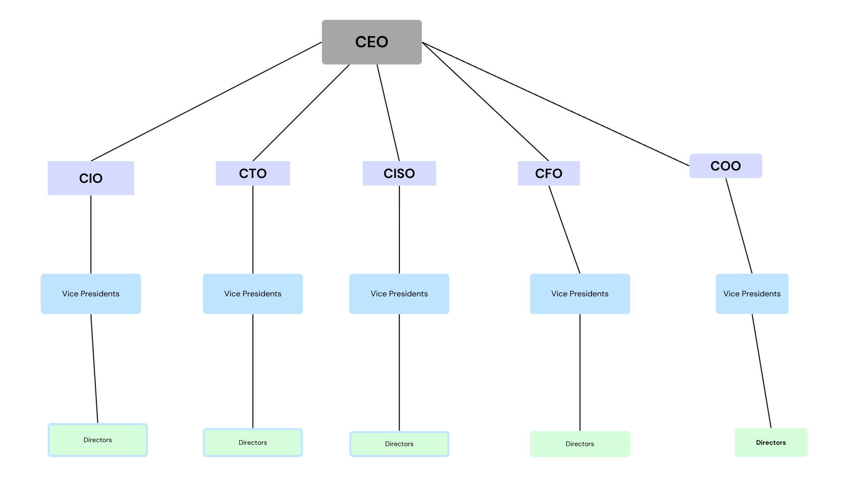
Figure 1.1 Diagram showing the organisational governance chart of a large IT enterprise.
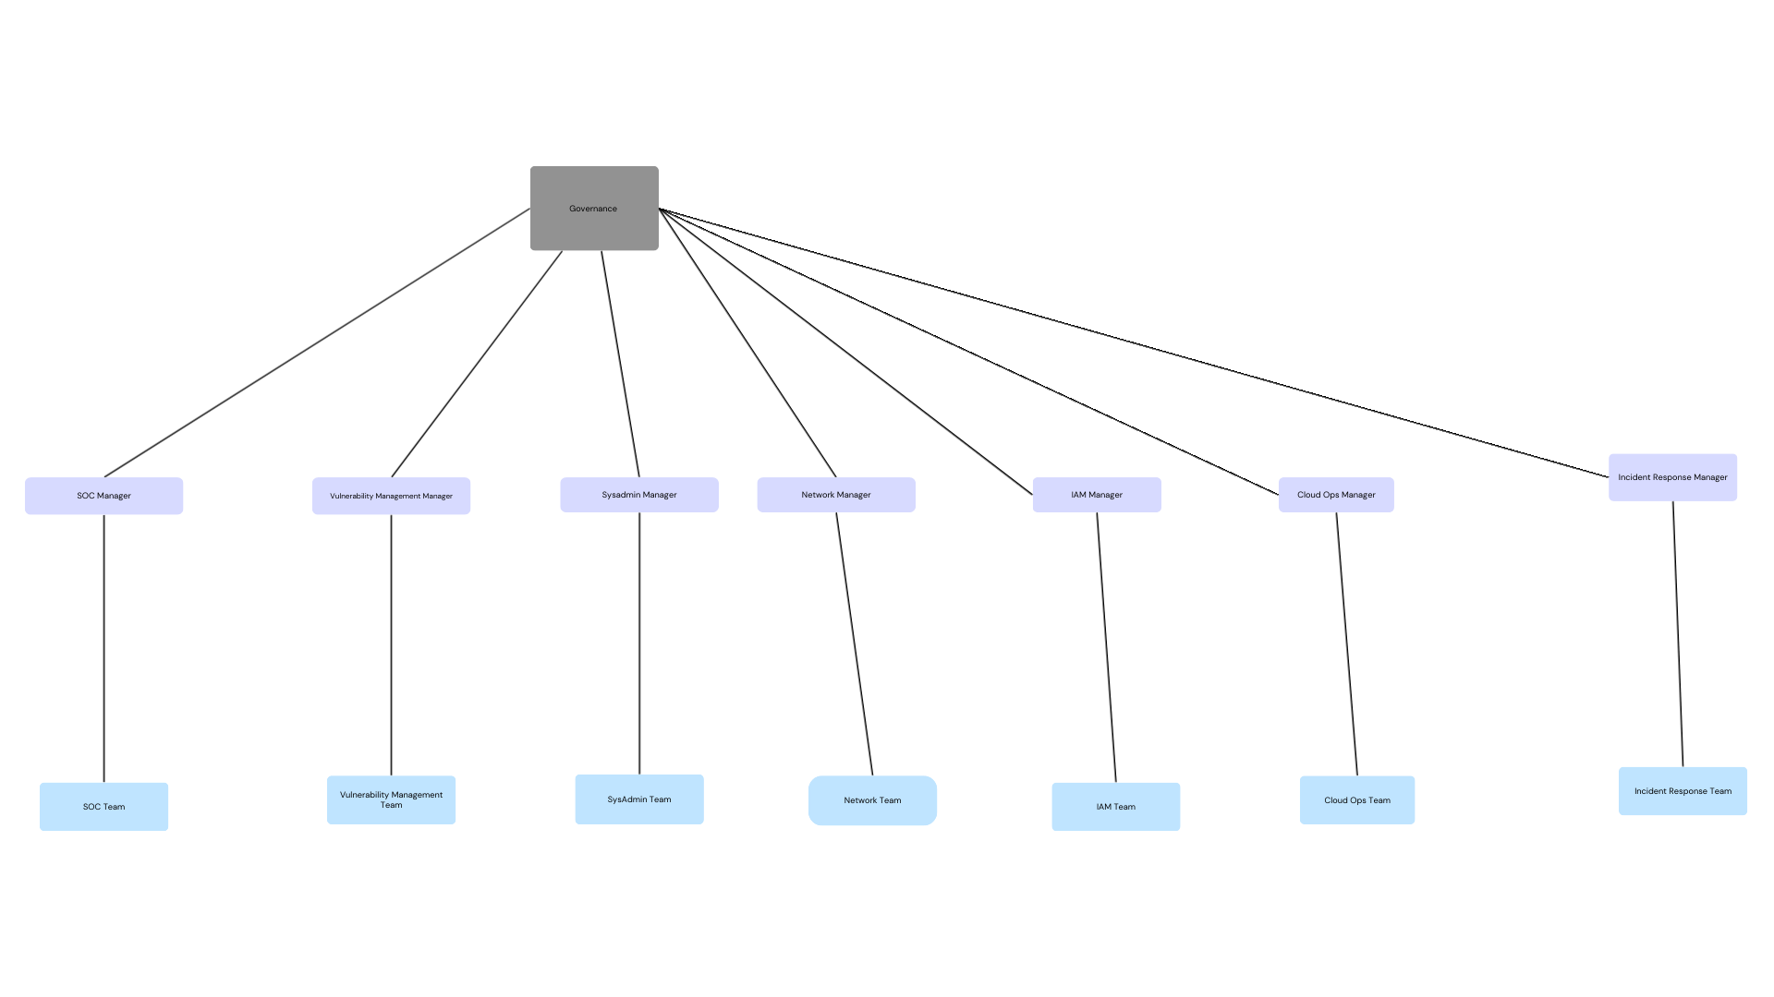
Figure 1.2 Diagram showing the organisational management chart of a large IT enterprise.
RACI Matrix for Ransomware Policy Creation:
Roles | R | A | C | I
CEO |  |  |  | –
CIO |  |  |  | –
CTO |  |  |  | –
CISO |  | –
CFO |  |  |  | –
Managers | –
Teams |  |  | –
RACI Matrix for Ransomware Policy Implementation:
Roles | R | A | C | I
Governance |  |  |  | –
CISO |  | –
SOC Manager |  |  | –
Vulnerability Management Manager | –
SysAdmin Manager | –
Network Manager | –
IAM Manager | –
Cloud Ops Manager | –
Incident response manager |  |  | –

Strategy
The purpose of this document is to guide decisions on ransomware and to establish a clear stance against ransomware attacks. The scope of this document is restricted to all internal and external operational assets, the organisation's employees, customers, and third-party services. This document is intended for governance executives, IT operations, the legality team, the HR team, and the security team. As there is no completely secure network, this document assumes that real-time adaptability to limit impact matters more than eradicating all chances of breaches.
Attackers could penetrate the internal network through phishing, supply-chain compromise, exploitation of existing vulnerabilities, and the acquisition of unauthorised user access credentials. As we provide a software service to health service organisations, attackers would primarily target sensitive data gathered by health organisations, personally identifiable information obtained from our customers’ patients, and our internal systems, as they provide direct access to the networks of various significant healthcare organisations. As such, if we were to suffer a network breach, the resulting legal fines could be crippling to the organisation's finances. More than that, reputational damage to the organisation and to our existing and potential clients could become irreparable.
The strategic principles related to ransomware include:
- Zero-trust architecture by default.
- Offline and remote backups are of paramount importance to the organisation.
- Containment of impact is of higher priority than prevention.
- Ensure least privilege access at all levels.
- Data confidentiality is of higher priority to the organisation than data availability.
- Law enforcement must be contacted and informed within an hour of attack detection.
- If access has been gained to information present on the internal network, customers must be informed within an hour of detection.
Prevention Strategy:
- User access must be revoked within minutes of detecting anomalous activity.
- All unnecessary services are to be restricted, and defaults are to be immediately changed upon integration into the network.
- All unnecessary traffic must be filtered and flagged for monitoring.
- Compromised sections of the network should be isolated and taken offline immediately upon detection of compromise.
- Geolocation-based access control is to be enforced for third-party vendors.

Backup Recovery: The 3-2-1 backup rule is to be enforced. With 3 copies of data, 1 original copy plus 2 backups. The 2 backups are to be stored on 2 different media types: a local disc and a tape. And 1 copy is to be geographically separate from the primary copy. The recovery and recovery time of the backups are to be regularly tested, with the primary backup operational within 2 hours and the secondary copy operational within 72 hours.
Detection and Response Strategy:
- The SOC team must escalate any detections, according to their priority level, to the relevant personnel within 5 minutes of detection through the established communication channels.
- The SOC Manager is responsible for classifying suspected ransomware incidents and confirmed ransomware incidents.
- The SOC Manager is responsible for declaring an incident.
- The SOC team is responsible for escalating issues to the SOC manager. After the SOC manager has confirmed the incident's priority, the manager is to escalate the incident to the director, who is responsible for turning the incident report into an actionable document and presenting it to the CISO, who then presents it to the board for any necessary further actions.
- As defined in the strategic principles. Law enforcement is to be contacted within an hour of detection of a confirmed incident.
Organisation’s stance on Ransom: The organisation’s stance on the payment of ransom is no payment under any conditions, with local law enforcement encouraging but not enforcing the non-payment of ransoms. This decision has been made by the CEO on all matters, and no factor would influence the organisation's stance on the payment of ransoms.
Communications Strategy:
- Internal Comms Principles: As it relates to ransomware, the HR team is to define internal communications in the event of a ransomware attack, emphasising clarity, consistency, timeliness, need-to-know basis communication and channel appropriateness.
- As defined in the strategic principles, customers must be alerted within an hour if access is gained to information present on the network.
- Incidents must be reported to the relevant regulatory organisations within 72 hours of detection.
- The CIO is the only individual authorised to disclose information about a ransomware incident to the media; all other individuals within the organisation are to refrain from disclosing unauthorised organisational information.

Governance and Accountability:
- The CISO has been assigned the responsibilities and obligations of the ransomware policy.
- The policy is to be reviewed annually.
- Key metrics such as backup success rate, mean time to respond, mean time to backup, and staff training completion rate should be measured, documented, and presented to the CISO at the end of every quarter.
Continuous Improvement: Lessons learned after incidents, threat intelligence from other relevant organisations, and regular tabletop exercises must be conducted to keep the organisation proactive rather than reactive.

Policies
Governance Structure: This policy defines the governance structure for ransomware policy management within the organisation, with the CEO and other relevant C-suite members overseeing the policy's strategic direction and the CISO responsible for creating and overseeing it.
Roles and Responsibilities:
CEO: Coordinates with other C-suite members to make strategic decisions regarding the policy.
CISO: Overall responsibility for creation and management of the ransomware policy.
Vice President: Assist the CISO in general management of the ransomware policy.
Director: Serves as a bridge between the governance layer and the management layer and is responsible for the translation of the high-level strategy of the policy into an implementable format.
Managers: Responsible for the general implementation of the policy.
Teams: Responsible for carrying out the operations required to implement the policy.
Strategic Objectives: The policy's strategy is to ensure the confidentiality of data within the organisation's network at all levels, with as much security at each level as is necessary to protect the highlighted information.
Policies and Standards: This policy supports a plan-do-check-act lifecycle used to incorporate new policies into the existing information security management system, as defined in the ISO 27001 standard (ISO 27001:2022).
Regulatory Compliance: As the organisation falls under the European large IT enterprise dealing with health information, it is subject to the GDPR (EUR-LEX, 2016), the EU AI Act (EUR-LEX, 2024), the Digital Services Act (EUR-LEX, 2022a), the EU Data Act (EUR-LEX, 2023), and the NIS2 Directive (EUR-LEX, 2022b).
Budget and Allocation: Based on the CISO's approved risk control strategy for each identified ransomware risk, the director of security operations is to consult management before selecting the most cost-effective tools and techniques to detect and prevent ransomware attacks.
Risk Management Approach: The organisation will follow a checklist-based approach to the identified ransomware risks and implement appropriate risk control strategies where necessary.
Risk Appetite: As the organisation handles sensitive healthcare information, the tolerance for ransomware risks is minimal, and any identified ransomware risks should be treated with the utmost seriousness.
Risk Assessment Process: Identification of ransomware risks is to be based on the latest industry-relevant risks and threat intelligence gathered on the organisation and other relevant organisations. Each identified risk should not be treated as a singular issue but as part of a larger contextual scenario within the organisation. Mitigations of each identified risk should be evaluated and approved or recalibrated by the CISO.
Control Objectives: The overall objective of implementing ransomware security controls is to develop a proactive, zero-trust approach across all situations.
Control Implementation: Implementation of controls includes, but is not limited to, MFA at all levels of access in the organisation, geolocation-based role-based access for internal and third-party vendors, and firewall filtering to restrict unnecessary traffic.
Control Monitoring and Auditing: Managers are to conduct a group tabletop exercise at the end of each quarter to review the effectiveness of the implemented ransomware controls.
Incident reporting and escalation: All employees must report any detected incidents to the incident response team through pre-established communication channels.
Incident Response Plan: The incident response manager is to prepare a detailed report that outlines the access containment, incident detection, response, and operational recovery phases in a layered, adaptable format.
Post-incident analysis: The incident response manager is responsible for organising post-incident review exercises 7 business days after the incident has been detected and operations have resumed.
Training and Education Programmes: All employees must provide evidence of completion of ransomware awareness training within 6 months of the programme's introduction, with regular updates on new ransomware developments sent through the pre-established communication channels.
Continuous Monitoring: SIEM and IDP systems are to be configured with the ransomware security controls to detect and prevent ransomware incidents.
Audits and Review: The CISO is to conduct an internal policy audit biannually, with an external general audit of the network's policy status conducted annually.
Reporting: The director of security operations is to compile security incidents into an actionable format for executive management to make strategic decisions.
Review and Update Cycle: The policy is to be reviewed once every 2 years and promptly updated with immediate urgency if any issues are discovered during periodic internal and external audits.
Feedback Mechanisms: Feedback from the operational team and management will be regularly gathered and compiled by the director of security operations into a high-level strategic document, which executive management will use to assess the security status of existing controls.

Procedure
Ransomware Prevention Procedures (Netwrix, n.d.):
- Avoid giving regular users administrative rights on their machines.
- Ensure that antivirus software and endpoint protection solutions are kept updated.
- Keep all operating systems and applications fully patched within 2 weeks of release.
- Close all unnecessary ports in the firewalls.
- Implement network segmentation.
- Confine user-owned devices to the guest network.
- Block known ransomware extensions using the file resource manager.
Ransomware Incident Response Procedures (Exabeam, n.d.):
- Each member of the incident response team must perform pre-assigned responsibilities in the event of an incident.
- An exhaustive list of all hardware and software assets related to ransomware is to be compiled.
- Critical business functions, applications, and backups are to be listed, documented, and made accessible to all relevant parties at all times.
- Lessons learnt during simulations and actual attacks are to be documented and accessible to all relevant parties at all times.
Ransomware Governance and Compliance Procedures (ICO, 2025):
- Continuously review, establish, and communicate a set of appropriate security policies that provide direction to the suitable levels of security.
- Identify, document and classify identified personal data.
- Determine and document appropriate controls to protect processed personal data.
- Ensure all staff have a basic awareness of ransomware attacks.
- Continuously review and update disaster recovery and business continuity plans to help restore personal data promptly.

Management
Operational Security Practices:
- The network security manager must oversee network segmentation controls related to ransomware.
- The SOC manager must conduct regular simulated attacks to train the SOC team to identify the patterns of a real attack.
- The vulnerability management manager must oversee regular vulnerability scans of the organisation's internal network every fortnight.
- The IAM manager must oversee the flushing of old credentials and the regular update of password-based access immediately upon discontinuation of employee and at the end of every quarter as an ongoing exercise.
- The sysadmin manager must oversee the recovery and operational availability exercises over the organisation’s internal network at the end of every month.
- The incident response manager must conduct regular incident response and tabletop exercises to ensure the organisation remains proactive.
- The incident response manager is to oversee employee training on ransomware and help them understand the overall importance of the risks it poses.
Technical controls and prevention:
- Firewalls should be configured to restrict all unnecessary ports and traffic to systems on the internal network.
- SIEM systems should be configured to detect anomalous and contextually abnormal activity in the network.
- IDS and IPS systems should also be configured to combine real-time and historical data to detect anomalous network activity.
- Anti-malware software should be configured to block all known malicious extensions.
- Email filtering systems should be configured to flag and temporarily block all unknown domains entering the network, notify the vulnerability management team, and then forward them to the original destination or discard them.
Response and Recovery:
- The network manager is to oversee the quick isolation of compromised networks in the event of an incident.
- The SOC manager is to oversee the quick detection and escalation of priority to all other security departments.
- The vulnerability management manager is to oversee the isolation and analysis of the detected anomaly.
- The IAM manager is to oversee the termination of all compromised user access credentials.
- The sysadmin manager oversees the continuous operation of critical business assets and ensures the rapid re-availability of business operations in the event of an incident.
- The cloud ops manager is to oversee the analysis of any abnormal activity during the cloud platform's regular operations.
- The incident response manager is to oversee the general response to detected incidents in the pre-established order and document lessons after the attack has been resolved.

Collaboration
Before an Attack:
The relationship between governance and management should be properly aligned before the occurrence of an incident through:
- Joint tabletop exercises: Governance and management teams should conduct a general exercise at the end of each quarter to ensure alignment between the business requirements for creating the ransomware policy and its implementation by management.
- Request input from management during policy creation by governance; this will ensure alignment between business requirements and policy implementation.
- Communication protocols: Pre-established lines of communication must be in place to ensure regular review of requirements as the business and external requirements of the organisation evolve.
During an Attack:
- The CISO should coordinate with the incident response manager to handle incidents in a strategic and operational manner while addressing the organisation's multiple governance and management requirements.
- A pre-agreed escalation pathway must be established between management and the CISO to ensure there is no delay between the occurrence of an incident and the corresponding response from the organisation's governing body.
- Pre-agreed alternative communication channels must be established between management and governance in the event that primary communication channels become unavailable.
After an attack:
- Post-incident review should include significant input from both the governance body and the management body to align lessons learned from the incident with future actions to be taken by the organisation.
- Every poor response during the incident must be accountable to an individual in the organisation. Due to pre-agreed accountability structures, the individual must explain the reasons for the delayed response during the incident to help the governance body develop more robust approaches for the next incident.
- The ransomware policy is updated based on what was learnt from the incident, with the governance body responsible for implementing the changes and the management body responsible for approving them.
Continuous Improvement:
It is of utmost importance to ensure continuous monitoring and adaptation of policies to evolving internal and external factors, as even a single poorly handled incident can leave the organisation in a regulatory and reputational quagmire. A security posture that was previously sufficient two years ago might be severely lacking by then; this leaves the organisation in a dangerous position regarding its compliance with regulatory bodies.
Role of Governance in continuous improvement: The governance body should ensure annual policy review, allocation of budget when new tools or control gaps have been identified as a requirement, and the implementation of metrics-driven governance where the performance indicators are measured against other relevant organisations to determine average security stature compared to the rest of the industry.
Role of Management in continuous improvement: Management should ensure the continuous review and refinement of tools according to current best security practices, proactively detect new vulnerabilities as related to the organisation through vulnerability updation databases rather than wait to react to incidents, ensure regular penetration testing of present systems and conduct risk assessment exercises, and conduct an internal review in the event of an attack on another relevant organisation to determine the security posture and how to update it as compared to the affected organisation.

CONCLUSION
This document on the Televula organisation highlighted the organisation's background, the nature of ransomware, its dynamics and current mode of operation, relevant examples of affected organisations, and general methods of prevention against a ransomware attack. It then displayed an organisational and accountability structure and created a high-level strategic document aligned with the organisation's business requirements, relevant organisational policies related to ransomware, and general, implementable procedures to reduce the risk of ransomware within the organisation. The document also examined the implementation of the policy through the management body and the collaboration between management and governance to ensure a proactive, aligned approach to the detection and prevention of ransomware, in line with governance and management requirements. This document serves as a detailed guideline for implementing the ransomware policy across all levels of the organisation and must be referred to and adhered to by all employees in any decision relating to ransomware.

REFERENCES
Chainanalysis, T. 2026. Crypto Ransomware: 2026 Crypto Crime Report. Chainalysis. [Online]. [Accessed 7 March 2026]. Available from: https://www.chainalysis.com/blog/crypto-ransomware-2026/.
CISA n.d. #StopRansomware Guide | CISA. [Accessed 7 March 2026]. Available from: https://www.cisa.gov/stopransomware/ransomware-guide.
EUR-LEX 2022a. Directive - 2022/2555 - EN - EUR-Lex. [Accessed 7 March 2026]. Available from: https://eur-lex.europa.eu/legal-content/EN/TXT/?uri=CELEX%3A32022L2555.
EUR-LEX 2022b. Regulation - 2022/2065 - EN - DSA - EUR-Lex. [Accessed 7 March 2026]. Available from: https://eur-lex.europa.eu/legal-content/EN/TXT/?uri=CELEX%3A32022R2065.
EUR-LEX 2023. Regulation - EU - 2023/2854 - EN - EUR-Lex. [Accessed 7 March 2026]. Available from: https://eur-lex.europa.eu/legal-content/EN/TXT/?uri=CELEX%3A32023R2854.
EUR-LEX 2024. Regulation - EU - 2024/1689 - EN - EUR-Lex. [Accessed 7 March 2026]. Available from: https://eur-lex.europa.eu/legal-content/EN/TXT/?uri=CELEX%3A32024R1689.
EUR-LEX 2016. Regulation (EU) 2016/679 of the European Parliament and of the Council of 27 April 2016 on the protection of natural persons with regard to the processing of personal data and on the free movement of such data, and repealing Directive 95/46/EC (General Data Protection Regulation) (Text with EEA relevance) [Online]. [Accessed 7 March 2026]. Available from: http://data.europa.eu/eli/reg/2016/679/oj.
Exabeam n.d. Incident Response for Ransomware: 6 Key Elements and Critical Best Practices. Exabeam. [Online]. [Accessed 8 March 2026]. Available from: https://www.exabeam.com/explainers/incident-response/incident-response-for-ransomware-6-key-elements-and-critical-best-practices/.
FBI n.d. Ransomware. Federal Bureau of Investigation. [Online]. [Accessed 7 March 2026]. Available from: https://www.fbi.gov/how-we-can-help-you/scams-and-safety/common-frauds-and-scams/ransomware.
IBM 2024. AIX. [Accessed 27 December 2025]. Available from: https://www.ibm.com/docs/pl/aix/7.2.0?topic=p-ping-command.
IBM 2026. IBM 2026 X-Force Threat Index: AI-Driven Attacks are Escalating as Basic Security Gaps Leave Enterprises Exposed. IBM Newsroom. [Online]. [Accessed 7 March 2026]. Available from: https://newsroom.ibm.com/2026-02-25-ibm-2026-x-force-threat-index-ai-driven-attacks-are-escalating-as-basic-security-gaps-leave-enterprises-exposed.
ICO 2025. Ransomware and data protection compliance. [Accessed 8 March 2026]. Available from: https://ico.org.uk/for-organisations/uk-gdpr-guidance-and-resources/security/a-guide-to-data-security/ransomware-and-data-protection-compliance/.
Netwrix n.d. Guide to Ransomware Prevention Best Practices | Netwrix. [Accessed 8 March 2026]. Available from: https://netwrix.com/.
The ISO Council 2022. What is PDCA cycle in ISO 27001. THE ISO COUNCIL. [Online]. [Accessed 7 March 2026]. Available from: https://isocouncil.com.au/plan-do-check-act-iso-27001/.
Uberoi, A. 2026. February 2026: Recent Cyber Attacks, Data Breaches, Ransomware Attacks. [Accessed 7 March 2026]. Available from: https://www.cm-alliance.com/cybersecurity-blog/february-2026-recent-cyber-attacks-data-breaches-ransomware-attacks.

